If failed **AR_PUBLICATION_00010** Publication (afscme_oltp4 on 1604) that is **hq-sql16-to-redshift on DMS FAILED there are following steps to fix it:**

1. Connect to SQL SERVER **AFSSQL1604 as sql16admin** (psw same as for remote connection)
2. Go **Replication** on AFSSQL1604 --click on **+**
3. Go to **Local Publications**, Select **AR_PUBLICATION_00010 –that is publication of afscme_oltp4**

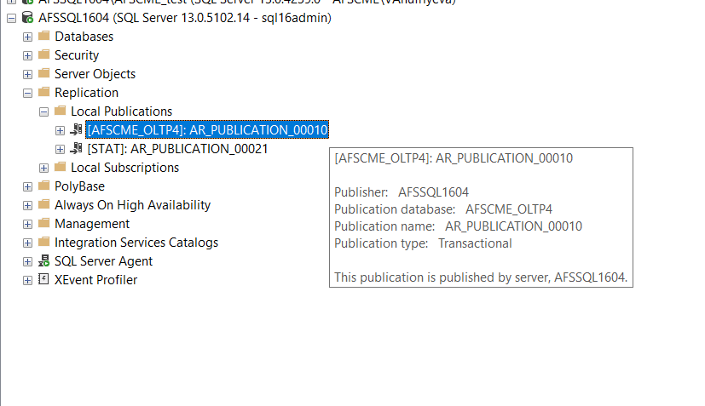

1. Right click on **AR_PUBLICATION_00010** Publication --go to **Properties**

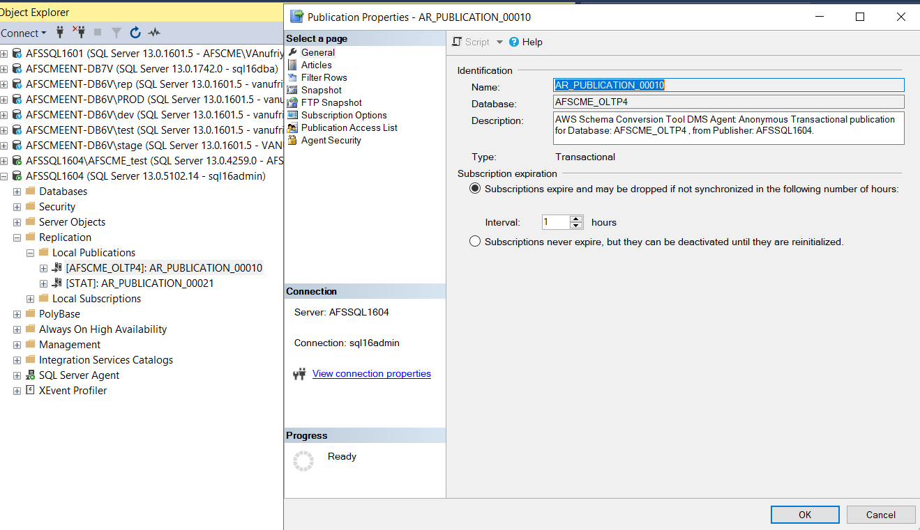

1. On Properties of **AR_PUBLICATION_00010** go to **ARTICLES**

And UNCHECK ALL of the articles and click OK.

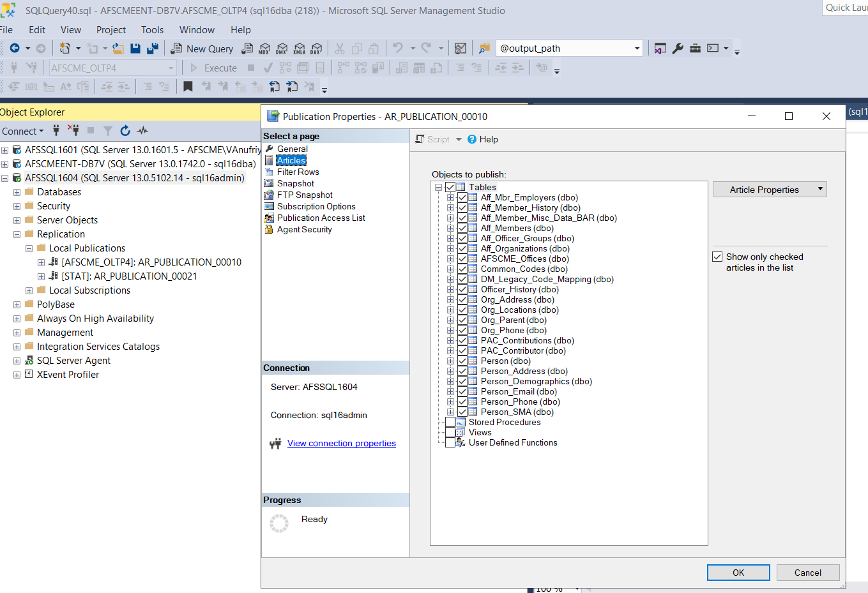

1. Let Lizzie and Derek know that you unchecked ALL of the articles and they can RESTART the AWS SIDE.
2. Either DBA or DW team goes to DMS dashboard AWS side to **RESTART**
3. To do that **Go to Action** and select **Restart** for **hq-sql16-to-redshift**

